|  |  |
| --- | --- |
|  |  |
| *Fig: Voltage across resistive load (DC Coupling) for low resistance* | *Fig: Voltage across resistive load (AC Coupling) for low resistance* |
|  |  |
| *Fig: Voltage across resistive load (DC Coupling) for medium resistance* | *Fig: Voltage across resistive load (AC Coupling) for medium resistance* |

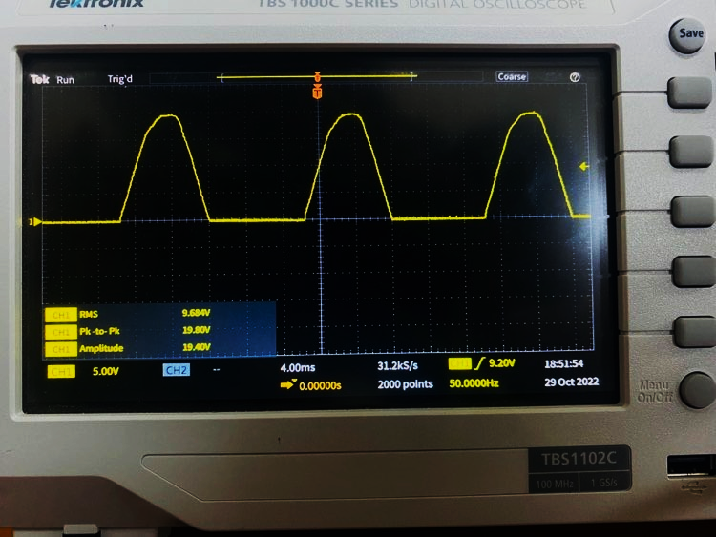

*Fig: Voltage across resistive load (DC Coupling) for high resistance*